# **Minikube Installation on Linux**

Minikube is a tool that makes Kubernetes run locally. It runs a single node cluster inside a VM. its the fastest way to run Kubernetes cluster mainly used for practicing and studying purpose.

Create EC2 Instance with Ubuntu OS and t2.large Processor

## **Install Kubectl on Linux**

curl -LO https://storage.googleapis.com/kubernetes-release/release/`curl -s [https://storage.googleapis.com/kubernetes-release/release/stable.txt`/bin/linux/amd64/kubectl](https://storage.googleapis.com/kubernetes-release/release/stable.txt%60/bin/linux/amd64/kubectl)

chmod +x ./kubectl

sudo mv ./kubectl /usr/local/bin/kubectl

kubectl version –client

## Install Docker

sudo apt-get update && sudo apt-get install docker.io -y

## Install Minikube

curl -Lo minikube https://storage.googleapis.com/minikube/releases/latest/minikube-linux-amd64 && chmod +x minikube

sudo mkdir -p /usr/local/bin/

sudo install minikube /usr/local/bin/

sudo apt install conntrack

minikube version

sudo -i

minikube start --vm-driver=none

minikube status

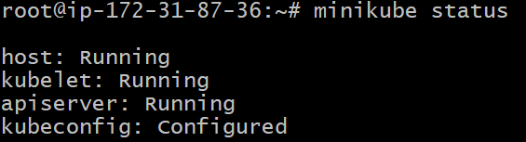

T2.large instance type pricing

[EC2 On-Demand Instance Pricing – Amazon Web Services](https://aws.amazon.com/ec2/pricing/on-demand/)

| **Instance name** | **On-Demand hourly rate** | **vCPU** | **Memory** | **Storage** | **Network performance** |
| --- | --- | --- | --- | --- | --- |
| t2.nano | $0.0058 | 1 | 0.5 GiB | EBS Only | Low |
| t2.micro | $0.0116 | 1 | 1 GiB | EBS Only | Low to Moderate |
| t2.small | $0.023 | 1 | 2 GiB | EBS Only | Low to Moderate |
| t2.medium | $0.0464 | 2 | 4 GiB | EBS Only | Low to Moderate |
| t2.large | $0.0928 | 2 | 8 GiB | EBS Only | Low to Moderate |
| t2.xlarge | $0.1856 | 4 | 16 GiB | EBS Only | Moderate |
| t2.2xlarge | $0.3712 | 8 | 32 GiB | EBS Only | Moderate |